Project: CMPG325-2026-150
Client: Lebone Communications(Klerksdorp)
Student name: 41362756
Submission date:02 October 2026

1.Project overview
This project presents a departmental network topology developed in Cisco Packet Tracer, consisting of two access-layer switches interconnected via a multilayer core switch. The core technical implementation focuses on inter-VLAN routing achieved through Switched Virtual Interfaces (SVIs). To fulfil the CR11 requirement, IP telephony with Voice VLAN support is integrated into the design.
2.Network topology
The multilayer core switch establishes connectivity to the access layer via GigabitEthernet0/1 for Department A and GigabitEthernet0/2 for Department B. Each departmental switch supports three endpoints: two workstations and an IP phone. Within each department, one workstation is directly connected to the access switch, whereas the second workstation is connected indirectly through the IP phone — the phone uplinks to the switch access port, and the PC connects to the phone’s integrated PC port, enabling both data and voice traffic on a single link via Voice VLAN.
Topology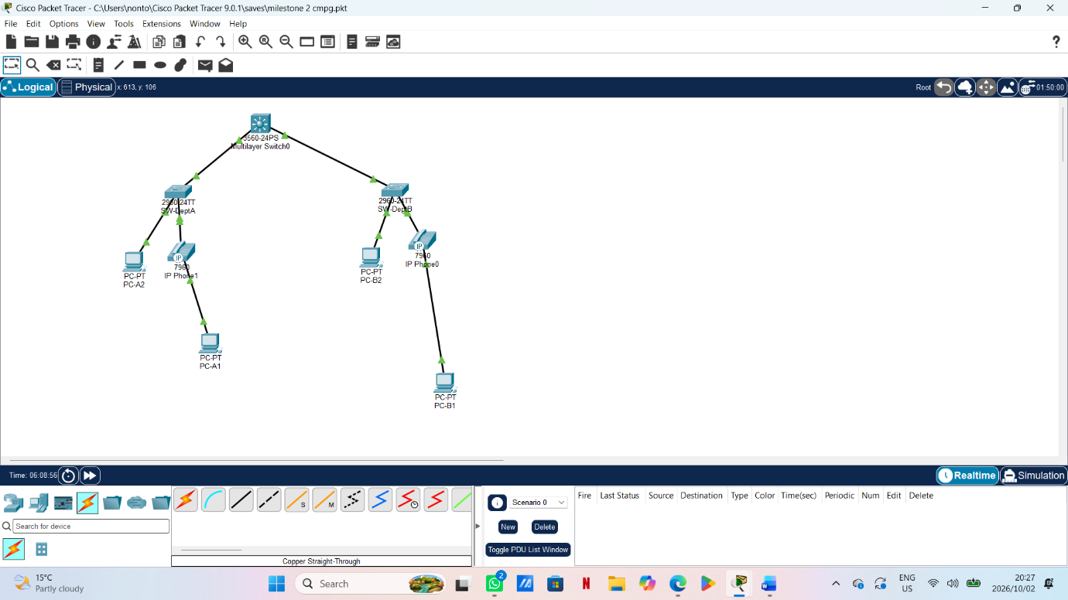
VLAN and IP addressing plan
Complete this table using the addresses and VLANs configured in your Packet Tracer file. The assigned address block is 172.30.102.0/23.
VLAN ID :10
Purpose: Department A
Subnet and mask:255.255.255.192
Default gateway:172.30102.1

VLAN ID:20
Purpose: Department B
Subnet/mask:255.255.255.192
Gateway IP:172.30.102.64

VLAN ID:30
Purpose: Voice
Subnet/mask:2 subnet
Gateway IP:172.30.0.0/26

Implementation
Departmental VLANs were provisioned on the access switches to achieve logical separation. The uplinks between the multilayer core and the departmental switches were configured as 802.1Q trunks. Switched Virtual Interfaces (SVIs) were created on the multilayer switch to serve as default gateways for each VLAN, with inter-VLAN routing enabled using the `ip routing` command.
Specifically, SW-DeptA interface Fa0/5 was set to access VLAN 10 with Voice VLAN 30, while SW-Dept.b interface Fa0/6 was set to access VLAN 20 with Voice VLAN 30. The trunk links Gi0/1 and Gi0/2 were configured to allow VLANs 10, 20, and 30. The core switch hosts Vlan10 (172.30.102.1/26) and Vlan20 (172.30.102.65/26), both in up/up state.
IP phones were connected to the departmental switches to satisfy the VoIP requirement. Voice VLAN 30 was configured on the relevant access ports, enabling the phones to obtain voice address while PCs remain in their respective data VLANs.

Figure 2: VLAN and trunk verification
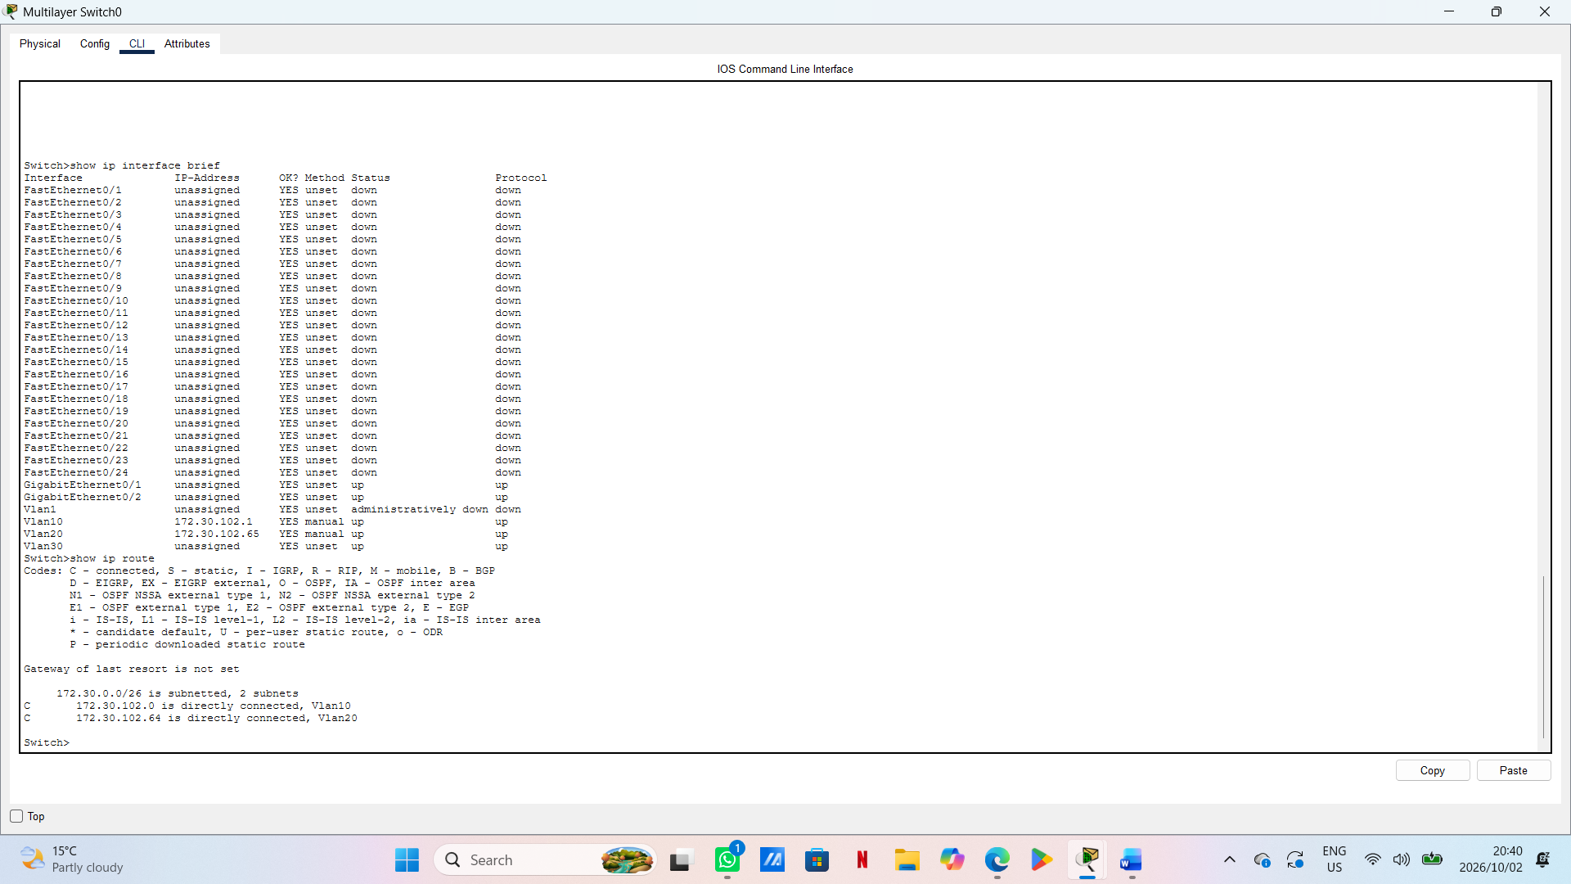

Figure3: SVI and routing
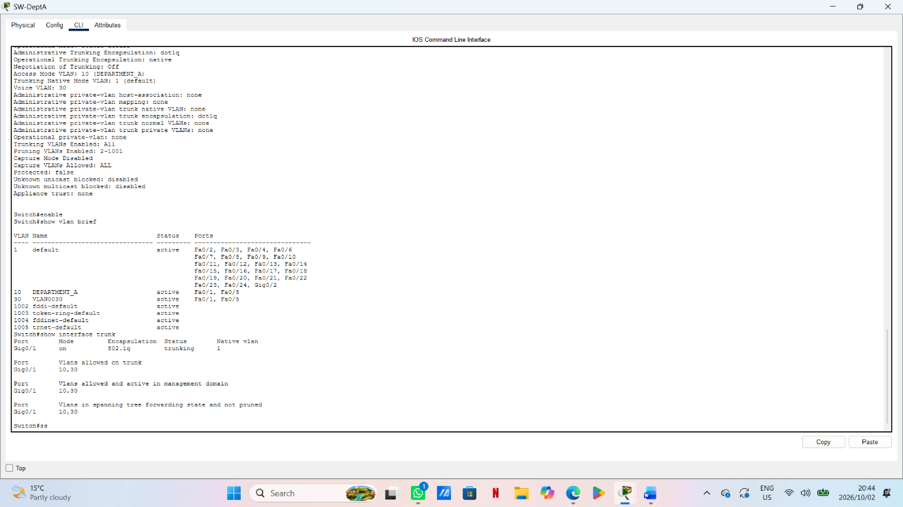
Testing
Test: Gateway test
Source: PC-A1 and VLAN 10
Destination:( Gateway IP):172.30.102.10
Result: Pass
Test: Inter VLAN test
Source: PC-B1 and VLAN 20
Destination:( PC in another VLAN and Ip):172.30.102.65
Result: Pass

Test: Voice test
Source: Phone
Destination: Test performed
Result: Not tested

Figure4: Connectivity testing
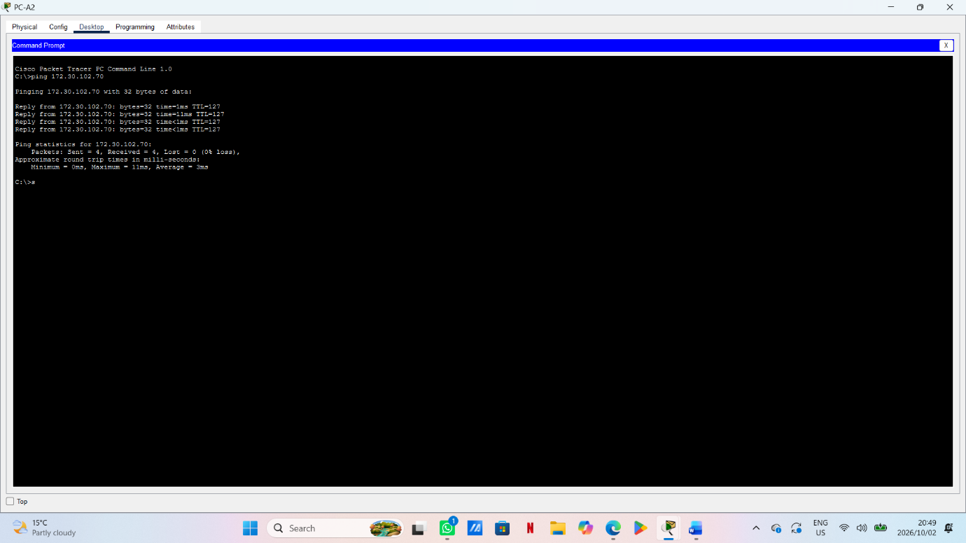
A successful ping to a gateway confirms connectivity to that gateway. To demonstrate inter-VLAN routing, include a successful ping between PCs in different VLANs.
6.Trouble shooting
A successful ping to a gateway confirms connectivity to that gateway. To demonstrate inter-VLAN routing, include a successful ping between PCs in different VLANs.
Conclusion
The network was implemented using two departmental access switches interconnected via a multilayer core switch. Logical separation was achieved through the configuration of VLAN 10 for Department A and VLAN 20 for Department B, with Voice VLAN 30 designated for IP telephony. Inter-VLAN communication was enabled via Switched Virtual Interfaces (SVIs) on the multilayer switch, configured as 172.30.102.1/26 for VLAN 10 and 172.30.102.65/26 for VLAN 20, with `ip routing` enabled. Connectivity was verified through trunk status (`Gi0/1` and `Gi0/2` allowing VLANs 10, 20, 30), SVI up/up state, and successful inter-VLAN ICMP tests between PCs in different VLANs (TTL=127), confirming routed traffic. Voice VLAN configuration on access ports Fa0/5 and Fa0/6 further satisfies the CR11 VoIP requirement.
References
1. Cisco Networking Academy. Cisco Packet Tracer 8.2.
2. Cisco Systems. Catalyst 3560 Multilayer Switch Configuration Guides — VLANs, Trunking,

https://github.com/Ntokie-2000/project-of-network.gitand Inter-VLAN Routing. https://www.cisco.com/c/en/us/support/switches/index.htm

